**PRACTICAL NO – 1**

**INTRODUCTION DESCRIPTION AND TO WIKIPEDIA**

**NAME – RUPAL SUNIL PATEL**

**ROLL NO – 59**

**CLASS – FYIT**

**1)DESCRIPTION ABOUT WIKIPEDIA AND ITS FEATURE**

**DESCRIPTION :**

Wikipedia was launched on January 15, 2001 by [Jimmy Wales](https://en.wikipedia.org/wiki/Jimmy_Wales) and [Larry Sanger](https://en.wikipedia.org/wiki/Larry_Sanger). Sanger coined its name as a [portmanteau](https://en.wikipedia.org/wiki/Portmanteau) of "[wiki](https://en.wikipedia.org/wiki/Wiki)" and "[encyclopedia](https://en.wikipedia.org/wiki/Encyclopedia)". It was initially an [English-language encyclopedia](https://en.wikipedia.org/wiki/English_Wikipedia), but versions in [other languages](https://en.wikipedia.org/wiki/List_of_Wikipedias) were quickly developed. With 6.2 million articles, the English Wikipedia is the largest of the 317 Wikipedia encyclopedias. Overall, Wikipedia comprises more than 55 million articles, attracting 1.7 billion unique visitors per month.

**FEATURES** **:**

Wikipedia [has been criticized](https://en.wikipedia.org/wiki/Criticism_of_Wikipedia) for its uneven accuracy and for exhibiting [systemic bias](https://en.wikipedia.org/wiki/Criticism_of_Wikipedia#Systemic_bias_in_coverage), including [gender bias](https://en.wikipedia.org/wiki/Gender_bias_on_Wikipedia), with the majority of editors being [male](https://en.wikipedia.org/wiki/Male) [Edit-a-thons](https://en.wikipedia.org/wiki/Edit-a-thon) have been held to encourage female editors and increase the coverage of women's topics. In 2006, [*Time*](https://en.wikipedia.org/wiki/Time_(magazine)) magazine stated that the open-door policy of allowing anyone to edit had made Wikipedia the biggest and possibly the best encyclopedia in the world, and was a testament to the vision of Jimmy Wales. The project's reputation improved further in the 2010s as it increased efforts to improve its quality and reliability, based on its unique structure, curation and absence of commercial bias. In 2018, [Facebook](https://en.wikipedia.org/wiki/Facebook) and [YouTube](https://en.wikipedia.org/wiki/YouTube) announced that they would help users detect [fake news](https://en.wikipedia.org/wiki/Fake_news) by suggesting links to related Wikipedia articles

**2)CREATING ACCOUNT ON WIKIPEDIA**

**STEP 1 :** Fill all your details in the given space and enter the captcha

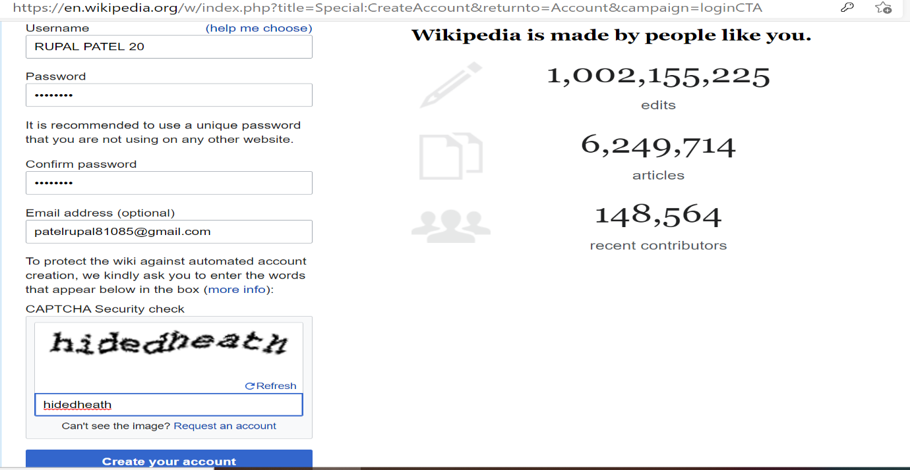

**STEP 2 :** This the created aacount

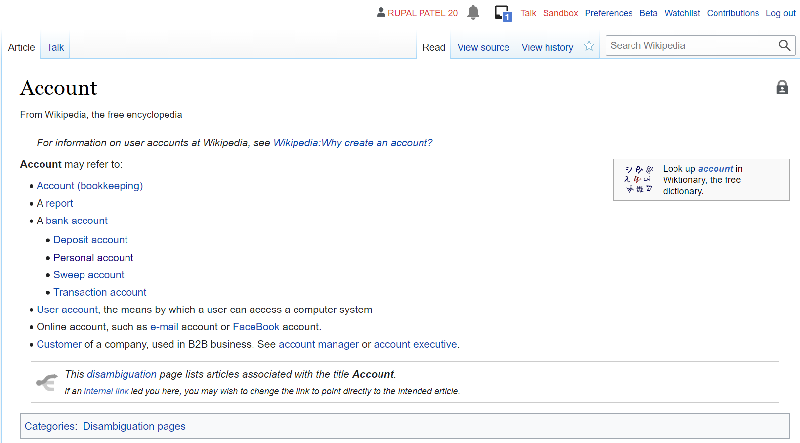

**3) CREATING YOUR PAGE ON WIKIPEDIA**

**STEP 1 :** Click on talk to create your own page

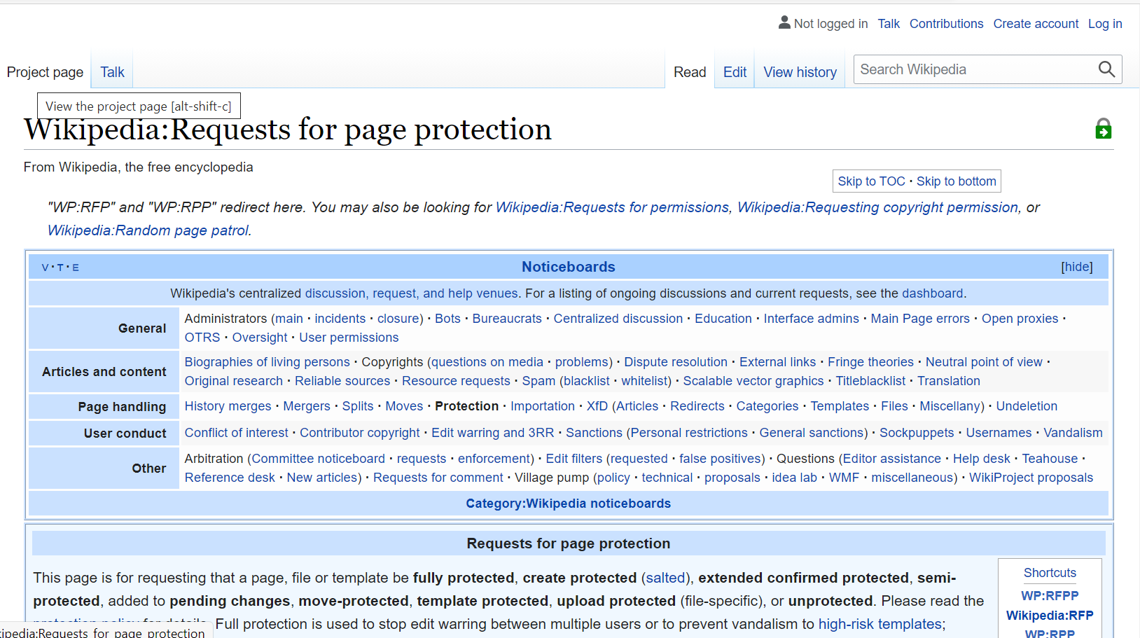

**STEP 2 :** Click on user page to create your own page

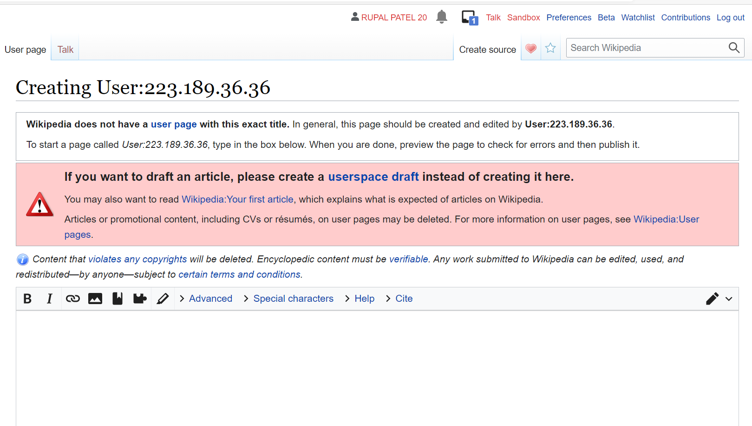

**STEP 3 :** Publish your page after making it

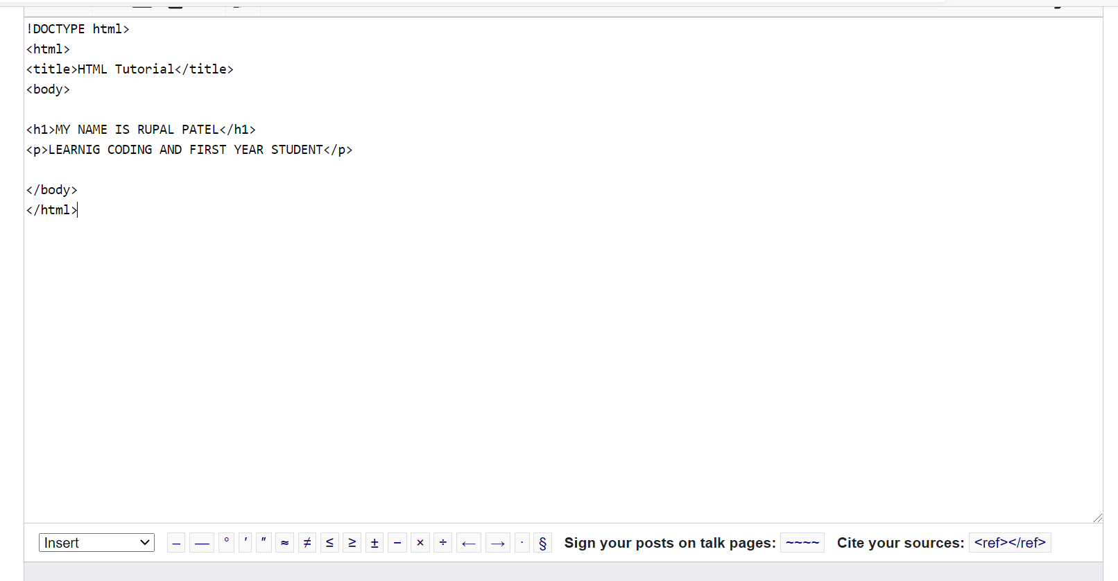

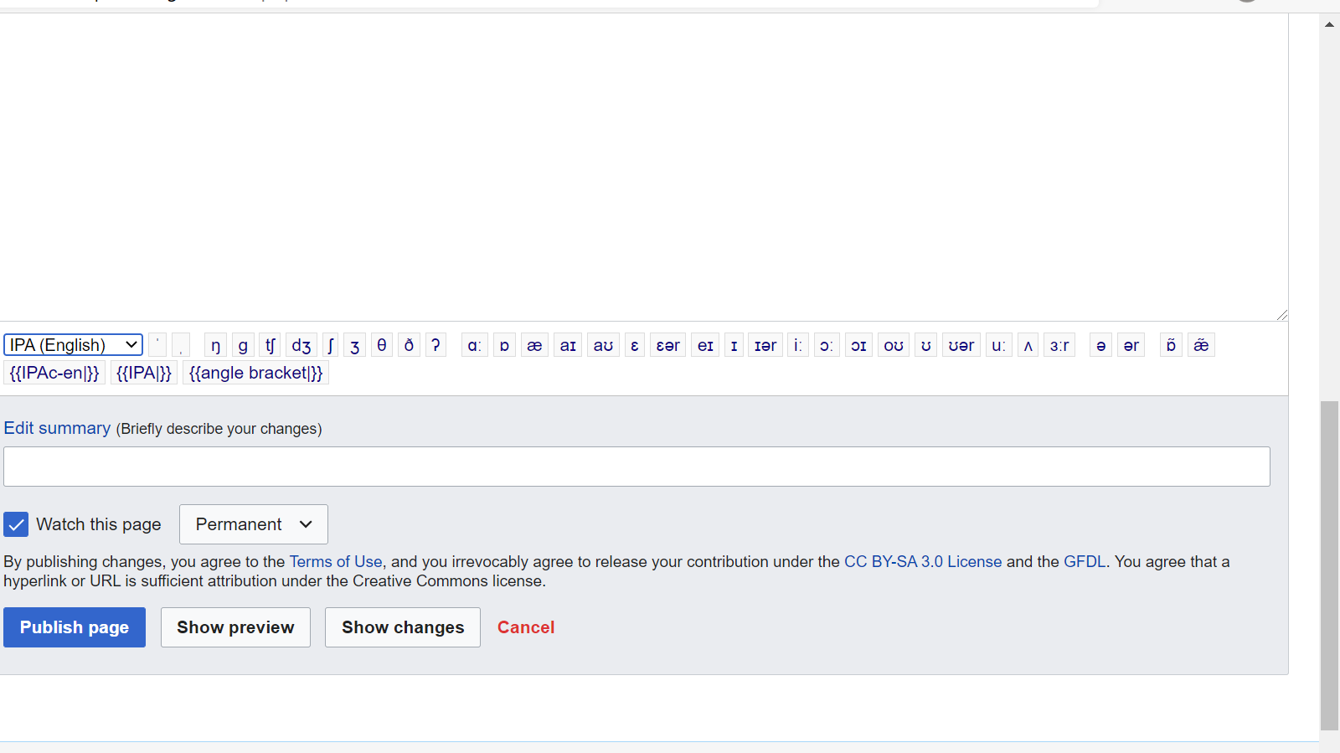

**4) EDITING YOUR PAGE ON WIKIPEDIA**

**STEP 1 :** We can edit or change our page after publishing it by click on edit page

